PROJECT DOCUMENTATION REPORT
MoodBloom
Daily Motivation and Mood-Tracking Application
MoodBloom is a daily motivation and mood-tracking app that goes beyond generic motivational quotes. Instead of offering random words of encouragement, it first asks how you're feeling and then suggests small, meaningful tasks tailored to your mood. These are the little things we often overlook, taking a short walk, practising gratitude, drinking water, taking a break, or acknowledging a small achievement, but they can make the biggest difference over time. With daily check-ins, personalized activities, and a virtual garden that grows alongside your progress, MoodBloom encourages you to nurture yourself one small step at a time.
Submitted in partial fulfillment of the requirements for
UI Design – Flutter (CS506PC) External Laboratory Examination
Particulars | Details
Student Name | Akella Vineela
Roll Number / Hall Ticket Number | 24XV1M0502
Programme & Branch | B. Tech - CSE
Institution | CR Rao AIMSCS
Academic Year | 2026 - 2027
Semester | III - I

Repository: https://github.com/A-Vineela/MoodBloom

1. Application Name and Introduction

1.1 Application Name
MoodBloom – Daily Motivation and Mood-Tracking Application

1.2 Introduction
MoodBloom is a daily motivation and mood-tracking application developed using Flutter and Dart. It is designed to help users understand their emotions, develop positive habits, and improve their daily well-being through small and meaningful activities.
Unlike traditional motivational applications that provide generic motivational quotes, MoodBloom focuses on the user's current emotional state. It allows users to record their daily moods and provides self-care activities based on how they feel.
The application includes five mood categories: Amazing, Good, Okay, Low, and Stressed. Based on the selected mood, users receive simple activities such as taking a short walk, practising gratitude, drinking water, taking a break, and writing down their thoughts.
One of the main features of MoodBloom is its virtual garden, where plants grow as users complete their daily self-care activities. This creates a visual representation of personal progress and encourages consistency. MoodBloom aims to make emotional well-being easier to maintain by reminding users that small positive actions can create meaningful changes over time.

2. Purpose and Objectives of the Application

2.1 Purpose
The main purpose of MoodBloom is to encourage users to develop a healthy relationship with their emotions and build positive daily habits. It provides a simple platform where users can track their moods, reflect on their feelings, and complete self-care activities suited to their selected mood.

2.2 Objectives
- Daily Mood Tracking: Allow users to record their emotional state through daily mood check-ins.
- Personalized Recommendations: Suggest suitable self-care activities based on the selected mood.
- Emotional Awareness: Encourage users to understand their emotions through reflections and mood history.
- Habit Development: Promote small positive habits such as drinking water, walking, resting, and practising gratitude.
- Virtual Garden Experience: Represent progress through a virtual garden where plants grow as care tasks are completed.
- Progress Monitoring: Help users review mood frequency and check-in activity through insights.
- User Engagement: Provide an interactive and visually appealing experience that encourages regular use.

3. Tools and Technologies Used
Tool / Technology | Purpose
Flutter | UI framework used to build the application and its interactive screens.
Dart | Programming language used for application logic and user interactions.
Visual Studio Code | Code editor used for project development (development environment).
Material 3 | Flutter design system used for UI components and styling.
shared_preferences | Flutter package used to store mood check-ins and garden-care progress locally.
JSON | Format used to encode and decode locally stored application data.
Git | Version-control system used to track source-code changes.
GitHub | Online repository used to host and maintain the project source code.
GitHub Actions | Automation service used to build and deploy the Flutter web application.
GitHub Pages | Static web-hosting platform configured for publishing the web build.

3.1 Flutter
Flutter is an open-source UI framework developed by Google. In MoodBloom, it is used to create the screens, layouts, navigation, and interactive components.

3.2 Dart
Dart is the programming language used with Flutter. It implements mood selection, check-in handling, activity recommendations, plant growth, and other application logic.

3.3 SharedPreferences
The shared_preferences package stores mood check-ins and completed garden-care tasks locally in the browser. This supports persistence across normal refreshes in the same browser profile.

3.4 Git and GitHub
Git manages source-code changes, while GitHub hosts the project repository and supports collaboration and version tracking.

3.5 GitHub Actions and GitHub Pages
GitHub Actions runs the automated Flutter web build and deployment workflow. GitHub Pages is configured as the static hosting destination for the generated web files.

4. Features and Functionalities Implemented

4.1 Daily Mood Check-in
Users can record how they feel by choosing one of five moods: Amazing, Good, Okay, Low, or Stressed. Each mood has its own emoji, colour, and short description.

4.2 Personalized Self-Care Activities
The garden provides three mood-sensitive care suggestions for each plant. Examples include taking slow breaths, drinking water, getting fresh air, stretching, sharing a kind word, or writing down something to be grateful for.

4.3 Daily Reflections
Users can optionally add a short reflection of up to 180 characters during a check-in. These notes can help users express their feelings and revisit their experiences.

4.4 Virtual Garden
Every mood check-in creates a plant in the personal garden. The plant's starting appearance reflects the recorded mood, and completing care tasks changes its growth stage.

4.5 Mood History and Recent Reflections
The dashboard can show recent check-ins and reflections, allowing users to revisit recent entries.

4.6 Mood Insights and Statistics
The insights screen summarizes the number of check-ins, identifies the most frequently recorded mood, and displays a distribution for all five moods.

4.7 Progress Tracking
The garden shows completed care tasks for each plant and updates its growth stage as tasks are completed.

4.8 Local Data Storage
Mood entries and completed garden tasks are saved locally using shared_preferences. Data remains available after normal browser refreshes in the same browser profile. It is not synchronized to a cloud account or across devices.

5. Important Code Snippets
The following snippets are taken from the MoodBloom source project. They illustrate the main implementation areas, including application startup, mood representation, mood check-ins, activity recommendations, plant growth, and local storage.

5.1 Application Initialization (lib/main.dart)
import 'package:flutter/material.dart';
import 'app.dart';
void main() {
WidgetsFlutterBinding.ensureInitialized();
runApp(const MoodBloomApp());
}
Explanation: This initializes the Flutter framework and launches the root MoodBloom application.

5.2 Mood Representation (lib/models/mood_entry.dart)
enum Mood {
amazing('Amazing', '😄', Color(0xFFFFD166), 'Full of energy'),
good('Good', '🙂', Color(0xFF9BCF9B), 'Feeling positive'),
okay('Okay', '😐', Color(0xFFA8C5D8), 'Taking it as it comes'),
low('Low', '😔', Color(0xFFB9A7D5), 'A little cloudy'),
stressed('Stressed', '😣', Color(0xFFE9A58F), 'Need a breather');
const Mood(this.label, this.emoji, this.color, this.subtitle);
final String label;
final String emoji;
final Color color;
final String subtitle;
}
Explanation: The Mood enumeration defines the five available moods. Each mood stores a label, emoji, colour, and subtitle so the same mood information can be reused throughout the application.

5.3 Saving a Mood Check-in (lib/screens/main_shell.dart)
Future<void> _saveEntries() async {
final prefs = await SharedPreferences.getInstance();
final data = _entries.map((entry) {
return {
'date': entry.date.toIso8601String(),
'mood': entry.mood.name,
'note': entry.note,
};
}).toList();
await prefs.setString(_entriesStorageKey, jsonEncode(data));
}
Explanation: Each mood entry is converted into a map containing its date, mood, and note. The list is encoded as JSON and saved locally using SharedPreferences.

5.4 Mood-Based Care Activities (lib/screens/garden_screen.dart)
List<String> _tasksFor(Mood mood) {
switch (mood) {
case Mood.amazing:
case Mood.good:
return [
'Take a moment to enjoy something you love ☀️',
'Share a kind word with someone 💗',
'Write down one thing you are grateful for 🌼',
];
case Mood.okay:
return [
'Take a few slow, deep breaths 🌿',
'Stretch or walk around for five minutes 🚶',
'Do one small thing you have been putting off 🌷',
];
case Mood.low:
return [
'Drink a glass of water 💧',
'Get a little fresh air or sunlight ☀️',
'Give yourself a kind, encouraging thought 💗',
];
case Mood.stressed:
return [
'Pause and take five slow breaths 🌬️',
'Step away from your screen for a moment 🌱',
'Write down what is on your mind, if you want to 💌',
];
}
}
Explanation: This function returns three care suggestions according to the mood associated with a plant. The suggestions are intended as optional, manageable self-care activities.

5.5 Virtual Plant Growth (lib/screens/garden_screen.dart)
String _plantEmoji(MoodEntry entry, int completed) {
final difficultMood =
entry.mood == Mood.low || entry.mood == Mood.stressed;
if (completed >= 3) return '🌸';
if (completed == 2) return '🌿';
if (completed == 1) return '🌱';
return difficultMood ? '🥀' : '🌰';
}
Explanation: The plant's visual representation changes according to the number of completed care tasks. The starting appearance also reflects whether the recorded mood was Low or Stressed. The plant can progress to a sprout, leafy plant, and flower as tasks are completed.

5.6 Saving Garden Progress (lib/screens/garden_screen.dart)
Future<void> _saveProgress() async {
final prefs = await SharedPreferences.getInstance();
final data = _completedTasks.map(
(key, value) => MapEntry(key, value.toList()),
);
await prefs.setString(_storageKey, jsonEncode(data));
}
Explanation: Completed task indexes are converted into lists, encoded as JSON, and stored locally. This allows the garden to restore the user's completed care tasks when the application is reopened.

6. Deployment Details
MoodBloom is a Flutter web application. The repository includes a GitHub Actions workflow that builds the Flutter web project and deploys the generated static files to GitHub Pages.

6.1 Deployment Platform and Tools
- Source-code repository: GitHub
- Application framework: Flutter Web
- Build automation: GitHub Actions
- Hosting destination: GitHub Pages
- Build output directory: build/web

6.2 Deployment Procedure
- The MoodBloom source code is maintained in the GitHub repository.
- The deployment workflow is stored in .github/workflows/deploy.yml.
- The workflow is triggered when code is pushed to the main branch. It can also be started manually using workflow_dispatch.
- GitHub Actions checks out the repository and sets up the stable Flutter channel.
- Project dependencies are installed using flutter pub get.
- Flutter creates an optimized web build using the release build command and the repository-specific base path.
- The build/web directory is uploaded as a GitHub Pages artifact.
- A deployment job publishes the artifact using the GitHub Pages deployment action.

6.3 Build Command
flutter build web --release --base-href "/${{ github.event.repository.name }}/"
Explanation: This command generates the optimized web version of the application. The base-href value is set to the repository path so that application assets and routes work under the GitHub Pages URL.

6.4 GitHub Actions Workflow
name: Deploy MoodBloom to GitHub Pages
on:
push:
branches:
- main
workflow_dispatch:
permissions:
contents: read
pages: write
id-token: write
jobs:
build:
runs-on: ubuntu-latest
steps:
- name: Checkout repository
uses: actions/checkout@v4
- name: Set up Flutter
uses: subosito/flutter-action@v2
with:
channel: stable
- name: Install dependencies
run: flutter pub get
- name: Build Flutter web
run: flutter build web --release --base-href "/${{ github.event.repository.name }}/"
- name: Upload web build
uses: actions/upload-pages-artifact@v3
with:
path: build/web
deploy:
environment:
name: github-pages
runs-on: ubuntu-latest
needs: build
steps:
- name: Deploy to GitHub Pages
id: deployment
uses: actions/deploy-pages@v4
Note: The repository contains this deployment workflow. To confirm the live deployment URL and successful deployment status, check the repository's Actions tab and Settings > Pages.

6.5 Project Repository
GitHub Repository: https://github.com/A-Vineela/MoodBloom
Published Website URL: https://a-vineela.github.io/MoodBloom/

7. Screenshots of the Application (UI Output)
The screenshots in this section should be captured from the running MoodBloom application. The placeholders below indicate where each screenshot should be inserted in the final submitted report.

7.1 Home Screen – MoodBloom Dashboard
The dashboard introduces the application and provides an overview of the user's mood-tracking journey. It includes check-in statistics, streak information, garden information, and recent reflections.
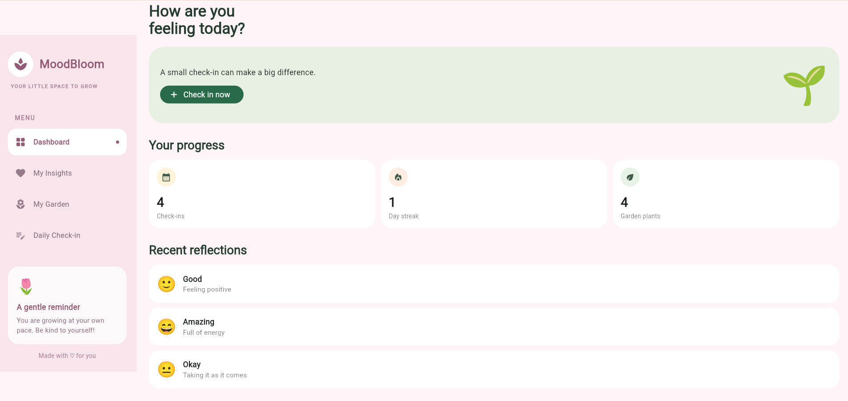

7.2 Daily Mood Check-in Screen
This screen allows users to select one of the five moods—Amazing, Good, Okay, Low, or Stressed—and optionally write a reflection of up to 180 characters.
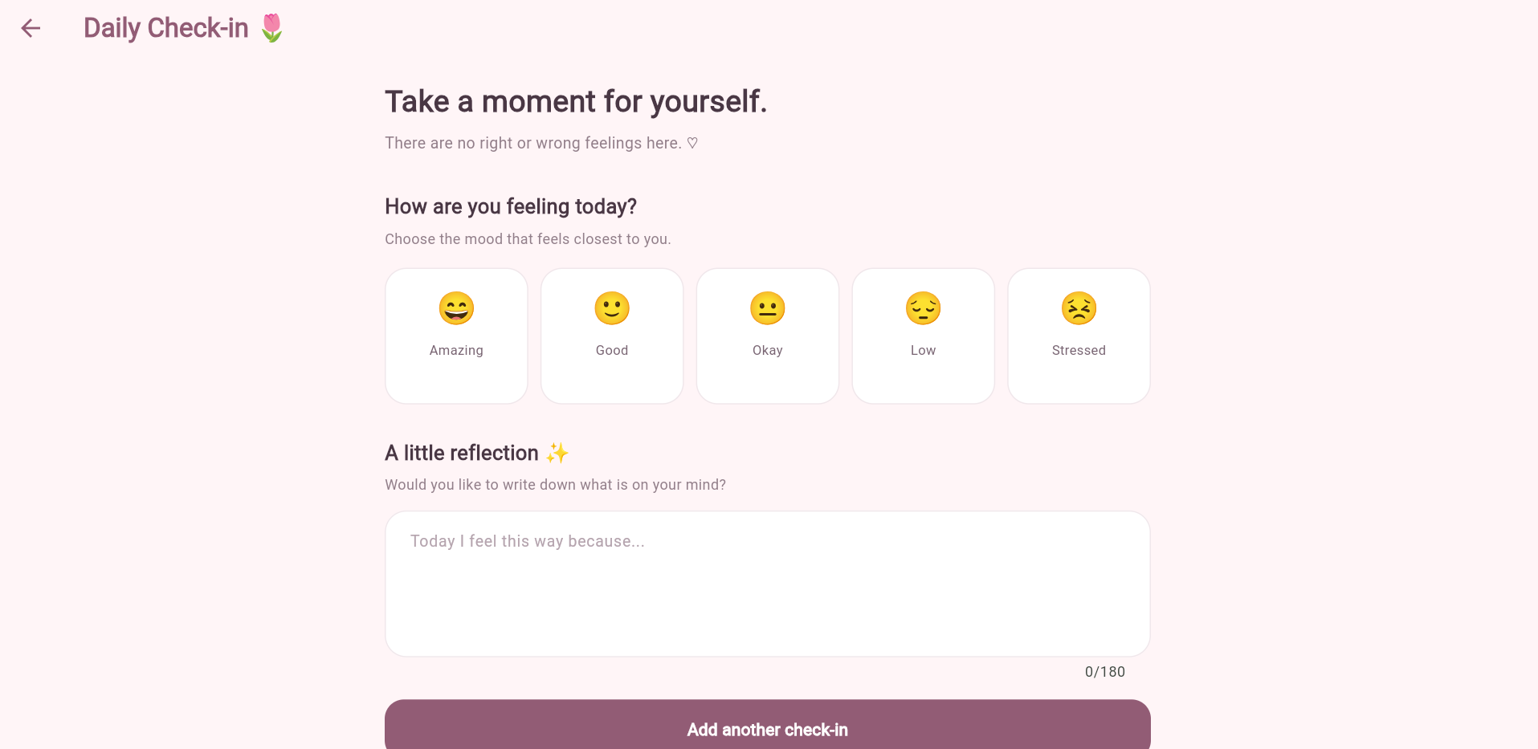

7.3 Personal Virtual Garden
Each mood check-in creates a plant in the garden. Users can complete the plant's care suggestions to move it through different growth stages.
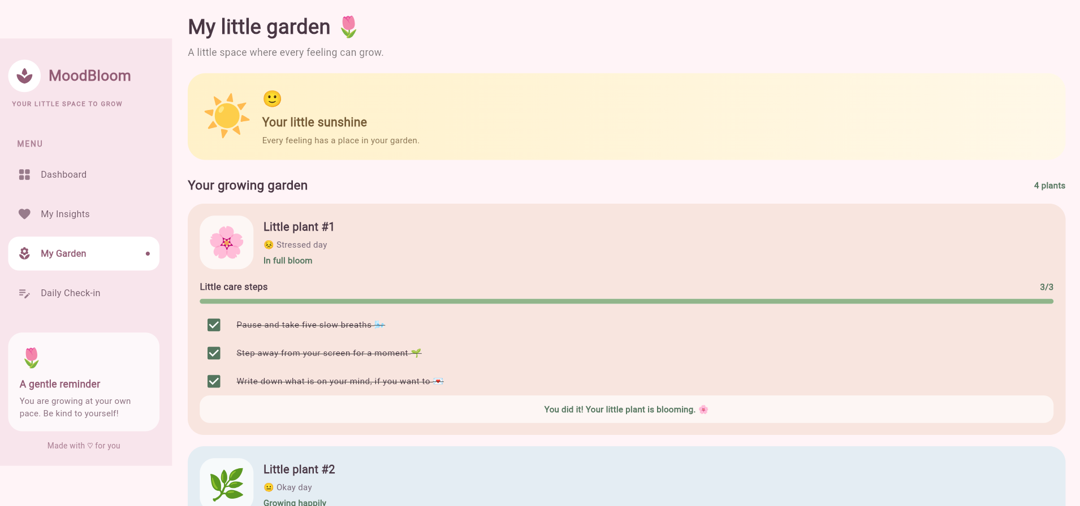
Figure: 7.3 Personal Virtual Garden

7.4 Mood Insights Screen
The insights screen displays the total number of check-ins, the most frequently recorded mood, and the distribution of all five moods.
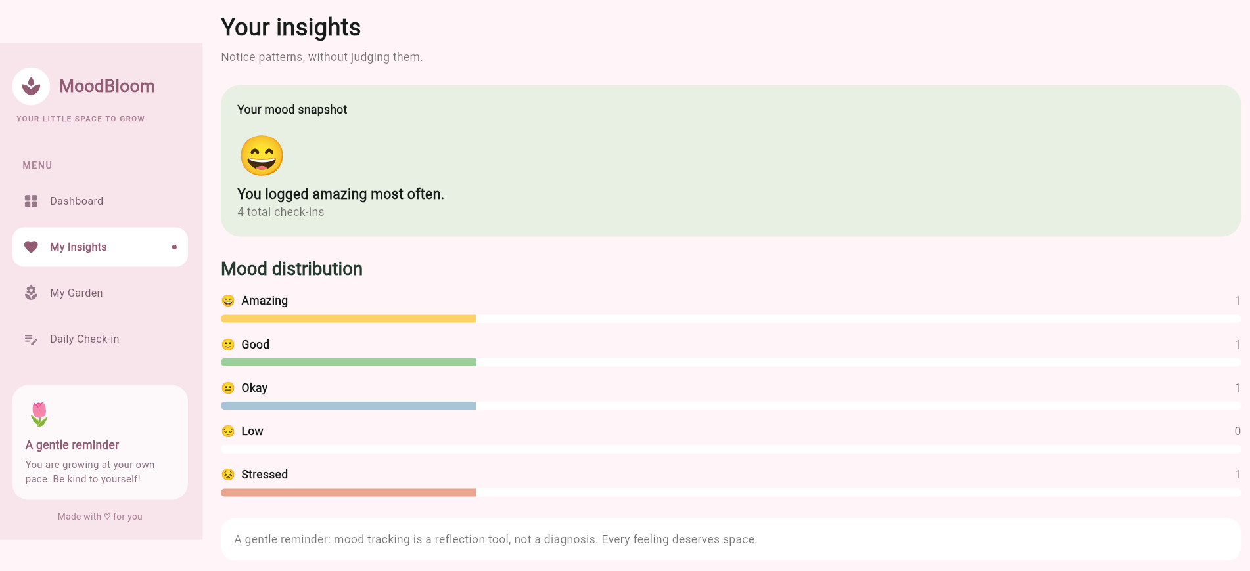

Project Repository
https://github.com/A-Vineela/MoodBloom

